**Topic: Adjacency matrix and shortest path**

Time: 45 mins Marks: /45 marks

**Calculator Assumed**



**Question One: [2, 3, 3: 8 marks]**

a) Construct the undirected graph from the adjacency matrix given.

A B C D E

$$\begin{matrix}A & \\ B & \\ C & \\ D & \\ E & \end{matrix}\left[\begin{matrix}0 & 1 & 1 & 1 & 0 \\ 1 & 0 & 0 & 0 & 2 \\ 1 & 0 & 0 & 1 & 1 \\ 1 & 0 & 1 & 0 & 0 \\ 0 & 2 & 1 & 0 & 0\end{matrix}\right]$$

b) Construct the digraph from the adjacency matrix given.

To

A B C D

From $\begin{matrix}A & \\ B & \\ C & \\ D & \end{matrix}\left[\begin{matrix}0 & 0 & 0 & 0 \\ 1 & 0 & 1 & 0 \\ 0 & 1 & 1 & 0 \\ 1 & 1 & 1 & 0\end{matrix}\right]$

c) Construct the adjacency matrix from the following digraph



**Question Two: [3, 2: 5 marks]**

Consider the following adjacency matrix for an undirected graph.

To

A B C D E

From $\begin{matrix}A & \\ B & \\ C & \\ D & \\ E & \end{matrix}\left[\begin{matrix}1 & 1 & 1 & 0 & 0 \\ 0 & 0 & 1 & 1 & 1 \\ 0 & 1 & 0 & 2 & 0 \\ 0 & 1 & 2 & 0 & 2 \\ 0 & 1 & 0 & 2 & 0\end{matrix}\right]$

The table below shows the distances between points on the graph.

|  |  |  |  |  |  |  |  |  |
| --- | --- | --- | --- | --- | --- | --- | --- | --- |
|  | A | B | C | | D | | E | |
| A | 5 km | 10 km | 12 km | |  | |  | |
| B | 10 km |  | 5 km | | 3 km | | 15 km | |
| C | 12 km | 5 km |  | | 9 km | 10 km |  | |
| D |  | 3 km | 9 km | 10 km |  | | 11 km | 12 km |
| E |  | 15 km |  | | 11 km | 12 km |  | |

a) Construct this graph.

b) Show on the network, the minimum spanning tree and state the total length of the minimum spanning tree.

https://ssl.gstatic.com/ui/v1/icons/mail/images/cleardot.gif**Question Three: [7 marks]**

Consider the following adjacency matrix for a digraph.

To

A B C D E

From

The table below shows the distances between points on the digraph.

|  |  |  |  |  |  |
| --- | --- | --- | --- | --- | --- |
|  | A | B | C | D | E |
| A |  | 10 km | 15 km |  |  |
| B |  |  | 5 km | 2 km | 25 km |
| C |  |  |  | 8 km | 20 km |
| D |  |  |  |  | 11 km |
| E |  |  |  |  |  |

Find the shortest distance from A to E.

**Question Four: [3, 2, 3: 8 marks]**

a) Consider the following graph drawn by an architect when designing a house. The graph shows possible access points to rooms. Each access point does not need to be a separate door.

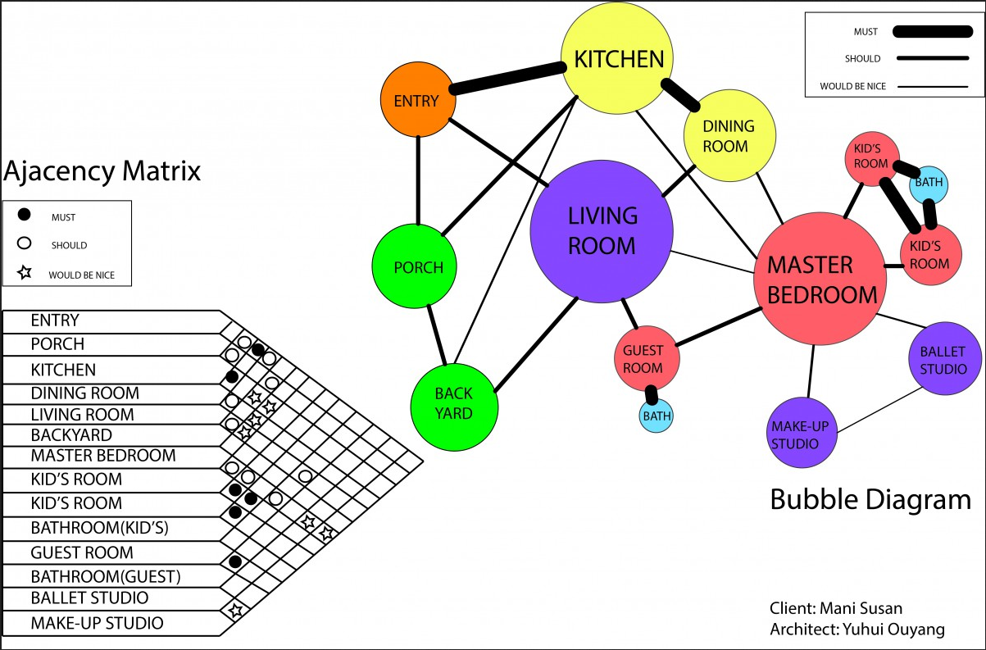

Souce: https://openlab.citytech.cuny.edu/arch3510design-v-sp14/2014/02/07/my-bubble-diagram-and-adjacency-matrixnew/

i) Draw an adjacency matrix for the communal part of the house. That is, the entry, porch, kitchen, dining, living and backyard. Include every possible entry point (must, should and would be nice), except those leading to parts of the house not considered in this matrix.

ii) The client is happy to remove a “would be nice” pathway provided they can easily make up this access going via one room only. Can all of the “would be nice” pathways be removed?

b) Graph the network relating to the following table.

**Question Five: [2, 2, 2, 2, 3, 2: 13 marks]**

The table below shows the distances (in kilometers) between Elsa, Anna, Kristoff, Hans, Olaf and Kai’s homes. The diagram (which is not drawn to scale) shows the positions of their homes.

|  |  |  |  |  |  |  |
| --- | --- | --- | --- | --- | --- | --- |
| Elsa | - |  |  |  |  |  |
| Anna | 0.5 | - |  |  |  |  |
| Kristoff | 5 | - | - |  |  |  |
| Hans | - | - | 6 | - |  |  |
| Olaf | - | 1.5 | 0.8 | 4 | - |  |
| Kai | 3 | 5 | - | 6 | 8 | - |
|  | Elsa | Anna | Kristoff | Hans | Olaf | Kai |



a) Complete the graph above showing all the paths shown in the table and label the paths with the correct distances.

b) What is the shortest distance from Elsa to Hans? State the distance and the path.

Elsa wants to go to Hans but she would like to collect Kai, Anna and Kristoff along the way. She does not want to go past anyone’s house twice and she also doesn’t want to travel on any paths twice.

c) Is it possible for Elsa to achieve this? If so state the path and distance of this journey.

d) What is the name given to the type of path described above.

e) Complete the table below to show how many routes via someone else, that there are in the graph above.

|  |  |  |  |  |  |  |
| --- | --- | --- | --- | --- | --- | --- |
|  | Elsa | Anna | Kristoff | Hans | Olaf | Kai |
| Elsa | 3 | 1 | 0 | 2 | 3 | 1 |
| Anna |  |  |  |  |  |  |
| Kristoff |  |  |  |  |  |  |
| Hans |  |  |  |  |  |  |
| Olaf |  |  |  |  |  |  |
| Kai |  |  |  |  |  |  |

f) State how many routes there are from Kai to Kristoff via one other person and state these route.

**Question Six: [2, 2: 4 marks]**

a) Consider the following undirected graph.

There are 5 routes from A to A of length 2. These routes are: A-B-A via the top path, A-B-A via lower path, A-B-A as a loop in one direction, A-B-A as a loop in the other direction and A-C-A.

Complete the table below to show how many walks of length 2 there are between the vertices in the graph above.

From

To

|  |  |  |  |  |  |
| --- | --- | --- | --- | --- | --- |
|  | A | B | C | D | E |
| A | 5 | 0 | 0 | 3 | 0 |
| B |  |  |  |  |  |
| C |  |  |  |  |  |
| D |  |  |  |  |  |
| E |  |  |  |  |  |

b) Show that the answer above can be found by squaring the adjacency matrix.

**Topic: Adjacency matrix and shortest path SOLUTIONS**

Time: 45 mins Marks: /45 marks

**Calculator Assumed**



**Question One: [2, 3, 3: 8 marks]**

a) Construct the undirected graph from the adjacency matrix given.

 A B C D E

$$\begin{matrix}A & \\ B & \\ C & \\ D & \\ E & \end{matrix}\left[\begin{matrix}0 & 1 & 1 & 1 & 0 \\ 1 & 0 & 0 & 0 & 2 \\ 1 & 0 & 0 & 1 & 1 \\ 1 & 0 & 1 & 0 & 0 \\ 0 & 2 & 1 & 0 & 0\end{matrix}\right]$$

b) Construct the digraph from the adjacency matrix given.

 To

 A B C D arrows

From $\begin{matrix}A & \\ B & \\ C & \\ D & \end{matrix}\left[\begin{matrix}0 & 0 & 0 & 0 \\ 1 & 0 & 1 & 0 \\ 0 & 1 & 1 & 0 \\ 1 & 1 & 1 & 0\end{matrix}\right]$

c) Construct the adjacency matrix from the following digraph

 To

From $\begin{matrix} & A & B & C & D & E & F \\ A & 0 & 1 & 0 & 0 & 0 & 0 \\ B & 0 & 0 & 1 & 0 & 1 & 1 \\ C & 0 & 0 & 1 & 0 & 0 & 1 \\ D & 0 & 1 & 0 & 0 & 0 & 0 \\ E & 0 & 0 & 0 & 1 & 0 & 2 \\ F & 0 & 0 & 0 & 0 & 0 & 0\end{matrix}$

**Question Two: [3, 2: 5 marks]**

Consider the following adjacency matrix for an undirected graph.

To

A B C D E

From $\begin{matrix}A & \\ B & \\ C & \\ D & \\ E & \end{matrix}\left[\begin{matrix}1 & 1 & 1 & 0 & 0 \\ 0 & 0 & 1 & 1 & 1 \\ 0 & 1 & 0 & 2 & 0 \\ 0 & 1 & 2 & 0 & 2 \\ 0 & 1 & 0 & 2 & 0\end{matrix}\right]$

The table below shows the distances between points on the graph.

|  |  |  |  |  |  |  |  |  |
| --- | --- | --- | --- | --- | --- | --- | --- | --- |
|  | A | B | C | | D | | E | |
| A | 5 km | 10 km | 12 km | |  | |  | |
| B | 10 km |  | 5 km | | 3 km | | 15 km | |
| C | 12 km | 5 km |  | | 9 km | 10 km |  | |
| D |  | 3 km | 9 km | 10 km |  | | 11 km | 12 km |
| E |  | 15 km |  | | 11 km | 12 km |  | |

a) Construct this graph.

b) Show on the network, the minimum spanning tree and state the total length of the minimum spanning tree.



**Question Three: [7 marks]**

Consider the following adjacency matrix for a digraph.

To

A B C D E

From

The table below shows the distances between points on the digraph.

|  |  |  |  |  |  |
| --- | --- | --- | --- | --- | --- |
|  | A | B | C | D | E |
| A |  | 10 km | 15 km |  |  |
| B |  |  | 5 km | 2 km | 25 km |
| C |  |  |  | 8 km | 20 km |
| D |  |  |  |  | 11 km |
| E |  |  |  |  |  |

Find the shortest distance from A to E.

Shortest path is A-B-C-D-E or A-C-D-E 34 km (4 marks for network including arrows and km, 2 marks for path and 1 mark for distance)

**Question Four: [3, 2, 3: 8 marks]**

a) Consider the following graph drawn by an architect when designing a house. The graph shows possible access points to rooms. Each access point does not need to be a separate door.



Souce: https://openlab.citytech.cuny.edu/arch3510design-v-sp14/2014/02/07/my-bubble-diagram-and-adjacency-matrixnew/

i) Draw an adjacency matrix for the communal part of the house. That is, the entry, porch, kitchen, dining, living and backyard. Include every possible entry point (must, should and would be nice), except those leading to parts of the house not considered in this matrix.



ii) The client is happy to remove a “would be nice” pathway provided they can easily make up this access going via one room only. Can all of the “would be nice” pathways be removed?

No, because then there would be no access to the Make-up Studio or and Ballet Studio

b) Graph the network relating to the following table.









**Question Five: [2, 2, 2, 2, 3, 2: 13 marks]**

The table below shows the distances (in kilometers) between Elsa, Anna, Kristoff, Hans, Olaf and Kai’s homes. The diagram (which is not drawn to scale) shows the positions of their homes.

|  |  |  |  |  |  |  |
| --- | --- | --- | --- | --- | --- | --- |
| Elsa | - |  |  |  |  |  |
| Anna | 0.5 | - |  |  |  |  |
| Kristoff | 5 | - | - |  |  |  |
| Hans | - | - | 6 | - |  |  |
| Olaf | - | 1.5 | 0.8 | 4 | - |  |
| Kai | 3 | 5 | - | 6 | 8 | - |
|  | Elsa | Anna | Kristoff | Hans | Olaf | Kai |





a) Complete the graph above showing all the paths shown in the table and label the paths with the correct distances.

b) What is the shortest distance from Elsa to Hans? State the distance and the path.

Elsa-Anna-Olaf-Hans 6 km

Elsa wants to go to Hans but she would like to collect Kai, Anna and Kristoff along the way. She does not want to go past anyone’s house twice and she also doesn’t want to travel on any paths twice.

c) Is it possible for Elsa to achieve this? If so state the path and distance of this journey.

 Yes, Elsa-Kai-Anna-Olaf-Kris-Hans 16.5 km

d) What is the name given to the type of path described above.

 Semi-Hamiltonian

e) Complete the table below to show how many routes via someone else, that there are in the graph above.

|  |  |  |  |  |  |  |
| --- | --- | --- | --- | --- | --- | --- |
|  | Elsa | Anna | Kristoff | Hans | Olaf | Kai |
| Elsa | 3 | 1 | 0 | 2 | 3 | 1 |
| Anna | 1 | 3 | 2 | 2 | 1 | 2 |
| Kristoff | 0 | 2 | 3 | 1 | 1 | 3 |
| Hans | 2 | 2 | 1 | 3 | 2 | 1 |
| Olaf | 3 | 1 | 1 | 2 | 4 | 2 |
| Kai | 1 | 2 | 3 | 1 | 2 | 4 |



f) State how many routes there are from Kai to Kristoff via one other person and state these route.

There are 3 routes. Kai-Elsa-Kris, Kai-Olaf-Kris, Kai-Hans-Kris

**Question Six: [2, 2: 4 marks]**

Consider the following undirected graph.

There are 5 routes from A to A of length 2. These routes are: A-B-A via the top path, A-B-A via lower path, A-B-A as a loop in one direction, A-B-A as a loop in the other direction and A-C-A.

a) Complete the table below to show how many walks of length 2 there are between the vertices in the graph above.

From

To

|  |  |  |  |  |  |
| --- | --- | --- | --- | --- | --- |
|  | A | B | C | D | E |
| A | 5 | 0 | 0 | 3 | 0 |
| B | 0 | 5 | 3 | 0 | 2 |
| C | 0 | 3 | 2 | 0 | 2 |
| D | 3 | 0 | 0 | 6 | 0 |
| E | 0 | 2 | 2 | 0 | 4 |



b) Show that the answer can be found by squaring the adjacency matrix.



$$\begin{matrix} & \begin{matrix}A & B & C & D & E\end{matrix} \\ \begin{matrix}A \\ B \\ C \\ D \\ E\end{matrix} & {\left[\begin{matrix}0 & 2 & 1 & 0 & 0 \\ 2 & 0 & 0 & 1 & 0 \\ 1 & 0 & 0 & 1 & 0 \\ 0 & 1 & 1 & 0 & 2 \\ 0 & 0 & 0 & 2 & 0\end{matrix}\right]}^{2}\end{matrix}=\begin{matrix} & \begin{matrix}A & B & C & D & E\end{matrix} \\ \begin{matrix}A \\ B \\ C \\ D \\ E\end{matrix} & {\left[\begin{matrix}5 & 0 & 0 & 3 & 0 \\ 0 & 5 & 3 & 0 & 2 \\ 0 & 3 & 2 & 0 & 2 \\ 3 & 0 & 0 & 6 & 0 \\ 0 & 2 & 2 & 0 & 4\end{matrix}\right]}^{}\end{matrix}$$